**TEAM ID:PNT2022TMID43906**

**Importing The Required Libraries**

import pandas as pd

import numpy as np

import seaborn as sns

from keras.datasets import mnist

from keras.layers import Dense, Flatten, MaxPooling2D, Dropout

from keras.layers.convolutional import Conv2D

from keras.models import Sequential

from tensorflow.keras.utils import to_categorical

import cv2

**Loading The Data**

(X_train, y_train), (X_test, y_test) = mnist.load_data()

**Analyzing The Data**

plt.imshow(X_train[0], cmap="binary")

plt.show()

print (y_train[0])

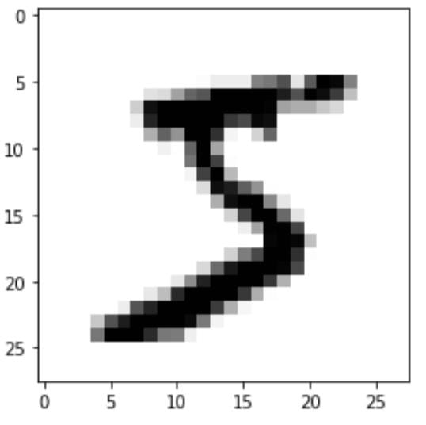

**Reshaping The Data**

print("---Before reshaping the Data---")

print("Shape of X_train: {}".format(X_train.shape))

print("Shape of y_train: {}".format(y_train.shape))

print("Shape of X_test: {}".format(X_test.shape))

print("Shape of y_test: {}".format(y_test.shape))

print("-----------------------------------------")

print()

print("---After reshaping the Data---")

X_train = X_train.reshape(60000, 28, 28, 1)

X_test = X_test.reshape(10000, 28, 28, 1)

print("Shape of X_train: {}".format(X_train.shape))

print("Shape of y_train: {}".format(y_train.shape))

print("Shape of X_test: {}".format(X_test.shape))

print("Shape of y_test: {}".format(y_test.shape))

print("-----------------------------------------")

---Before reshaping the Data---

Shape of X_train: (60000, 28, 28, 1)

Shape of y_train: (60000,)

Shape of X_test: (10000, 28, 28, 1)

Shape of y_test: (10000,)

-----------------------------------------

---After reshaping the Data---

Shape of X_train: (60000, 28, 28, 1)

Shape of y_train: (60000,)

Shape of X_test: (10000, 28, 28, 1)

Shape of y_test: (10000,)

-----------------------------------------